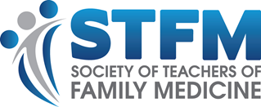

Scholarship for New Faculty to Attend the
Family Medicine Congressional Conference
Application Checklist

Contact Information:

Name: [Type text]

Suffix (MD, MPH, etc.): [Type text]

Email: [Type text]

Phone: [Type text]

Institution: [Type text]

City, State, Full Zip Code: [Type text]

Will you attend the FMAS in May in Washington, D.C.?

☐ Yes
☐ No

Have you completed the online advocacy course?

☐ Yes
☐ No

Provide contact information for your letter of recommendation.

☐ Name [Type text]

☐ Email [Type text]

Email this checklist and the following documents to Nina DeJonghe. Email ndejonghe@stfm.org.

☐ Chair or Program Director Letter of Recommendation
☐ Name and Email address of author of Letter of Recommendation
☐ Curriculum Vitae
☐ Essay*

*You are eligible for the scholarship if you do not have prior advocacy experience.

