CASE 1

Kendra is a 45 year old female with no past medical history who presents for her annual physical exam. She does not take any medications, is up to date on cervical cancer screening, and would like to wait until 50 to start mammograms. Her main concern today is her weight. She says “I try to eat healthy and exercise, but I just can’t lose any weight!” She requests “tests” to figure out why. She also wants to know if there is a diet and exercise plan you would recommend. She has heard from a friend there is “a pill” she can take to help her lose weight and is interested in that as well.

Family history: Diabetes (Mother, maternal GM), Hypertension (Father), CVA (paternal GF)
Social history: Nonsmoker, social EtOH use, lives with boyfriend
Surgical history: C-section x1, Cholecystectomy

ROS:
GEN: No fevers, chills, malaise
CV: No chest pain, DOE, edema
PULM: No cough, sputum production, SOB
GI: No abdominal pain, constipation, diarrhea
GU: No dysuria, frequency
NEURO: No weakness, numbness

Vital signs: BP: 137/88 mmHg HR: 84 bpm RR: 16 bpm BMI: 33

Physical Exam:
General: Obese, well appearing, NAD.
Head: Atraumatic, normocephalic
Cardiovascular: Regular rate and rhythm. No murmurs, rubs, gallops. Pulses intact bilaterally
Pulmonary: Comfortable work of breathing. Lungs clear to auscultation bilaterally. No wheezes, rales, rhonchi.
Abdomen: Soft, non-tender, non-distended. Bowel sounds present.
Extremities: No cyanosis, clubbing, edema.
Neurologic: Alert, oriented. CN II-XII grossly intact. No focal deficits.
Psychiatric: Mood and affect appropriate.

OBJECTIVES:
- Describe the following diets and indicate which have been shown to lead to sustained weight loss.
  - Weight Watchers, Paleo, Alkaline, Atkins
- Describe the following diets and indicate which have been shown to lead to sustained weight loss.
  - Mediterranean, DASH, Mayo Clinic Diet
- Which medications have been FDA approved for long term use in weight loss and what would you tell your patients about them?
  - What medications are FDA approved for short term use in weight loss?

CASE 1 Facilitator Guide
**slides from 2016 CME presentation by Hood Watson K. **

Questions 1 and 2 are meant for students to learn about diets with proven weight loss/health benefits as well as those that are “fad” diets but they may be asked about. Here is a good time to discuss that patients may ask about these or other diets they as physicians may need to look into if unaware of what they entail/risks/benefits.
  - Review USPSTF guidelines for obesity screening and intervention (multicomponent)
    - Talk about: motivational interviewing, choosemyplate.gov
    - Obtain food log: allows one to get more in depth information and find out what is the patient’s idea of healthy (discuss cultural/socioeconomic components)
  - Include exercise guidelines (review the basics: amount, moderate vs vigorous)
    - Amount
      - ≥150 minutes of moderate exercise a week
        - Moderate- walking 3.5mph, biking <10mph, gardening, dancing, water aerobics, doubles tennis
      - ≥75 minutes of vigorous exercise
        - Vigorous- jogging/running 5MPH, walking 4.5mph, bicycling >10MPH, heavy yard work, singles tennis, basketball, aerobics

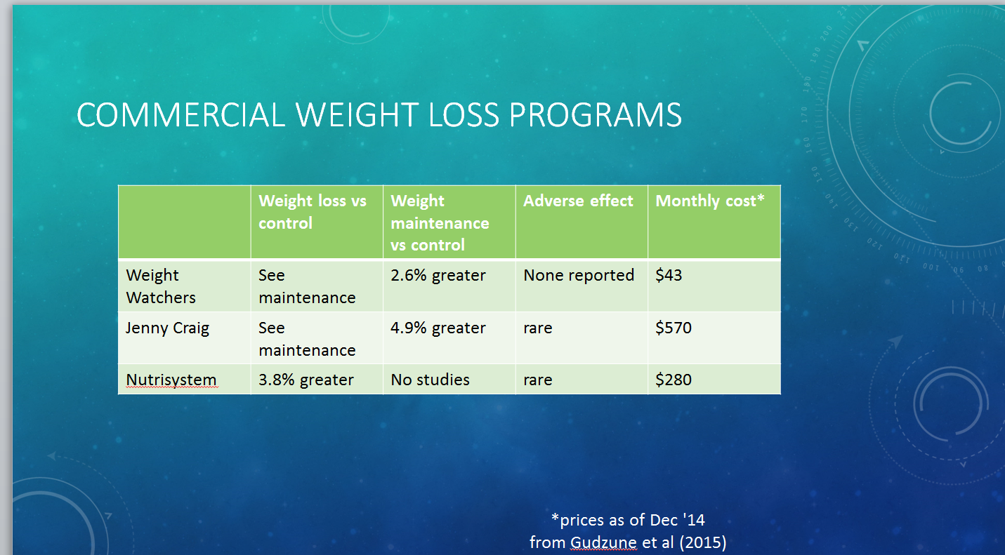
**slides from 2016 CME presentation by Hood Watson K. **
**slides from 2016 CME presentation by Hood Watson K. **
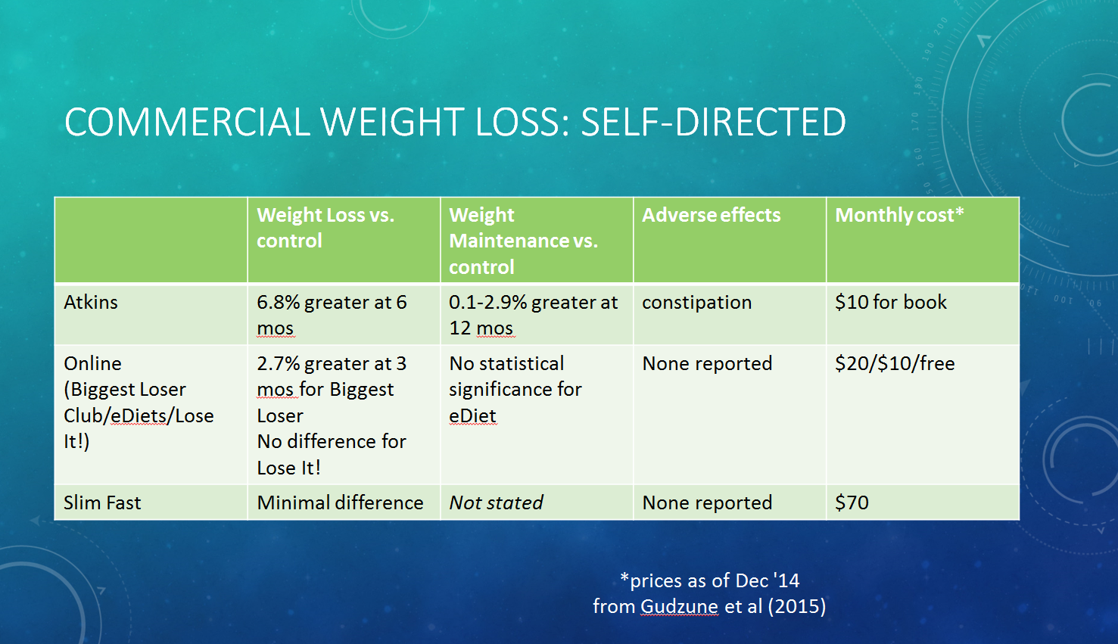
**slides from 2016 CME presentation by Hood Watson K. **
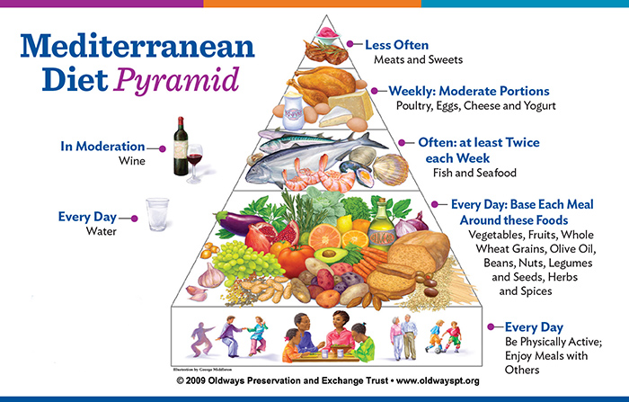
http://www.underwateraudio.com/blog/the-diet-guide-mediterranean-diet/
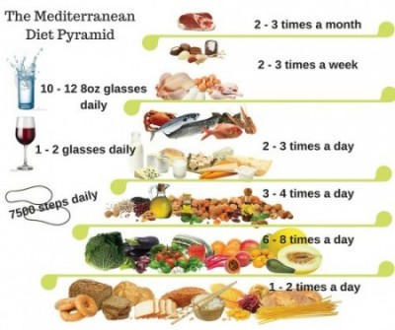
http://choiceslifestyle.com/why-a-mediterranean-diet/

Offers reductions in overall mortality, CV mortality, cancer incidence (breast, colorectal, prostate, etc) and mortality, incidence of Parkinson dz and Alzheimer dz.

Colditz GA. Healthy diet in adults. In UpToDate, Seres D (Ed), UpToDate, Waltham, MA. http://www.uptodate.com

Analysis of 16 reports shows that out of the 2,852 participants, 67.6% were female with an average mean age of 44.5 years (SD=9.8). A majority (75%) of the studies analyzed were conducted in Europe. There were significant decreases in weight, BMI, and WC from baseline to follow-up with the use of the Mediterranean Diet as the intervention (d+= -0.53, 95% CI from -0.79 to -0.25; d+= -0.49, 95% CI from -0.75 to -0.24; d+= -0.43, 95% CI from -0.75 to -0.09, respectively). Length of the intervention explained more than 50% of the variability of the effect sizes; the longer the intervention, the greater the reduction in obesity outcomes by 0.01 standard deviation of the effect per week. Conclusions: In addition to the well-known antiatherogenic effects of the MD, this diet appears to be effective in reducing obesity outcomes with increased effects when followed for longer periods of time.

Garcia M, Shook J, Kerstetter J, Kenny A, Bihuniak J, Huedo-Medina T. The efficacy of the Mediterranean Diet on obesity outcomes: A Meta-analysis. The FASEB Journal. 2015; 29(1)254.4.

Question 3
Review that stimulants (including phentermine) are FDA approved for short term use (12 or fewer weeks).
Also, discuss financial cost of long term and short acting weight loss medications.
Review: which medications are controlled, how you would describe them to patients (including how they work, side effects), and what would help to determine the best option for an individual.
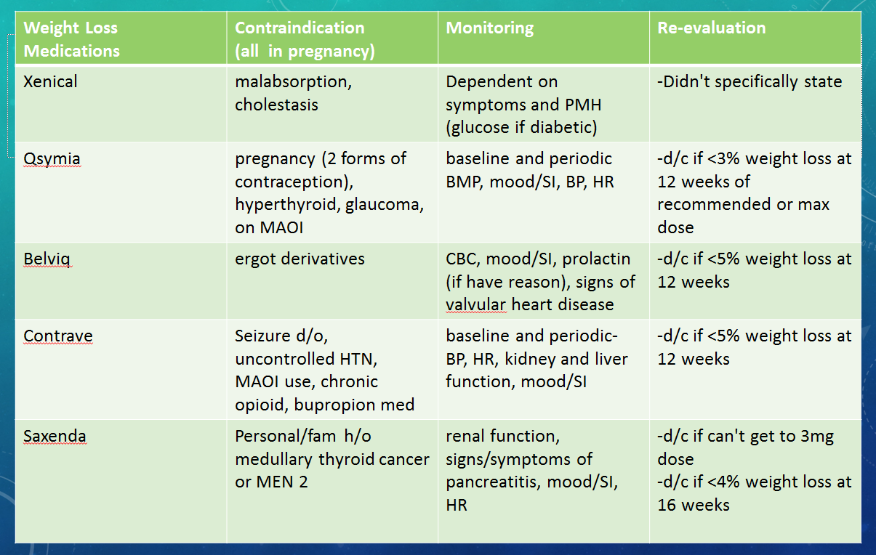
**slides from 2016 CME presentation by Hood Watson K. **

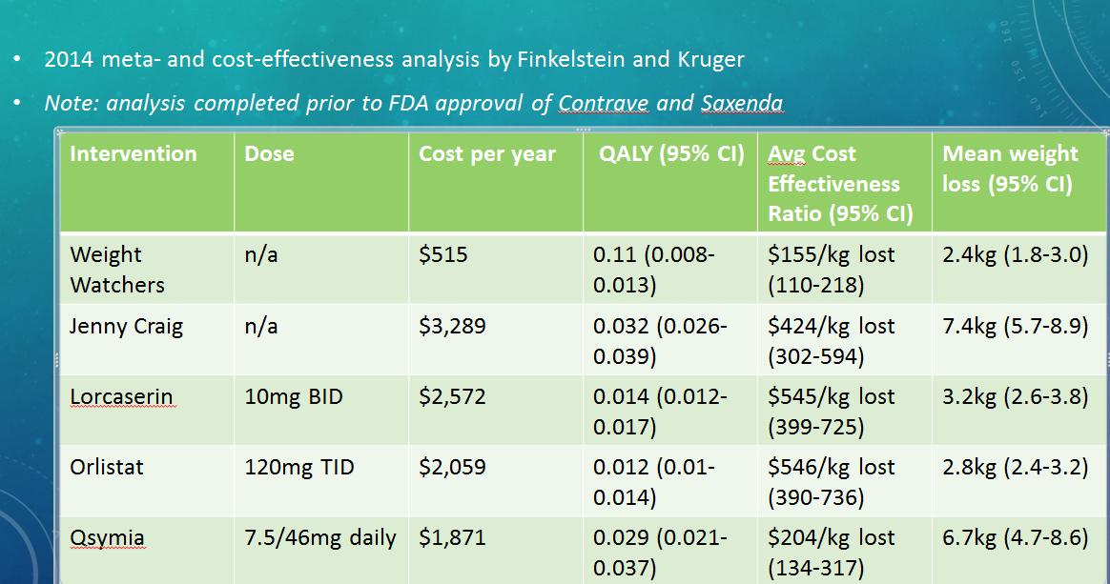
Finkelstein EA, Kruger E. Meta- and cost-effectiveness analysis of commercial weight loss strategies. Obesity 2014;22(9):1942-1951
**slides from 2016 CME presentation by Hood Watson K. **

CASE 2

Gary is a 60 year old male with a history of type 2 diabetes and hypertension who presents for diabetic follow up visit. He is without complaint but is frustrated by “having to take all of these medicines.” He does not think his diabetes pill is working because his blood sugars are always high when he checks them, especially after meals. He takes Metformin 1000mg twice daily and misses “only one dose every now and then.” In the past he was reluctant to add more medications but states he will think about it again now that his sugars are remaining high. He does not exercise, but works in construction and says he is active during the day. His most recent HgA1C was 9.6%. He has normal kidney and liver function. You ask him about his current diet, and he reports the following:

Breakfast: bowl of cheese Grits and 2 pieces of white toast
Lunch: Ham and cheese sandwich with mayo on a Hawaiian roll
Snacks: Lays mini barbque Potato chips or cheese & packet of Ritz crackers
Dinner: Bojangles 4 piece chicken tenders combo usually picked up on the way home.
Dessert: Little Debbie cake (1 or 2) and Blue Bell vanilla ice-cream (he cannot quantify)

Family history: Coronary artery disease (Father), Diabetes (Father), Hypertension (Mother)
Social history: Former smoker, daily EtOH use (1-2 light beers a day), lives with wife
Surgical history: None

ROS:
GEN: No fevers, chills, malaise
CV: No chest pain, DOE, edema
PULM: No cough, sputum production, SOB
GI: No abdominal pain, constipation, diarrhea
ENDO: + polyuria, polydipsia. No heat or cold intolerance.

Vital signs: BP 148/92 mmHg HR: 77 bpm RR: 14 bpm

Physical Exam:
General: Well appearing, NAD.
Head: Atraumatic, normocephalic
Cardiovascular: Regular rate and rhythm. No murmurs, rubs, gallops. Pulses intact bilaterally
Pulmonary: Comfortable work of breathing. Lungs clear to auscultation bilaterally. No wheezes, rales, rhonchi.
Abdomen: Soft, non-tender, non-distended. Bowel sounds present.
Extremities: No cyanosis, clubbing, edema. No foot ulcers.
Neurologic: Alert, oriented. CN II-XII grossly intact. Sensation intact to light touch and pinprick bilateral feet.
Psychiatric: Mood and affect appropriate.

QUESTIONS:
- What are the overall carbohydrate contents of Gary’s main meals and snacks? Please refer to online resources for nutritional information or food labels if needed.
- What is the fiber content of his typical day’s meal? How does it compare to the USDA recommendations for fiber intake? How will an increase in fiber affect his glucose levels and overall health?
- Gary asks if he can start going to Subway on the way home instead of Bojangles. Please compare the carbohydrate, sodium, fiber and fat content of his current meal versus a Subway oven roasted chicken sandwich. What do you inform him about the differences?
- Given his ongoing high sugars, you are concerned about waiting until his sugars improve so you recommend adding another medication. Which would you choose now and why?

Facilitator guide:
Ques 1: Carb contents. Students can use any available online or written resource to look up the amounts of carbs in the foods. Commonly used resources are MyFitnessPal, CalorieKing, FoodTracker and Calorie Lab. Amounts will vary somewhat based on the app/resource used, and this should also be a teaching point for the students. The varying amounts of starches is especially important for patients dosing their insulin by carb amount.
Breakfast: bowl of cheese Grits (40 grams) and 2 pieces of white toast (30 grams)
Lunch: Ham and cheese sandwich with mayo on a Hawaiian roll=approx. 16 grams
Snacks: Lays mini barbque Potato chips (22 grams)or cheese (unknown amount, perhaps 1 gm) & packet of Ritz crackers (how much is “a packet”? discuss! A serving of Ritz crackers is 5 crackers =10gm)
Dinner: Bojangles 4 piece chicken tenders combo usually picked up on the way home=41 grams in chicken alone. Remainder of carbs depends on what he chooses for the combo meal. Don’t forget to include drinks!
Dessert: Little Debbie cake (1 or 2)(depends on the cake! Each can range from 26-46 grams) and Blue Bell vanilla ice-cream (he cannot quantify)=assuming 1 cup which is two times rec serving, average is 40gms)

Question 2:
Fiber content. The purpose of this question is to show students how little fiber most adults get in their diets. It is shown that only about a third of Americans get the rec amount of fiber in their diets. The current rec :
According to the Institute of Medicine (IOM) (2002), dietary reference intake (DRI), an adequate intake for total fiber, is set at 38 and 25 gram (g) per day for young men (age 14-50 years) and women (age 19-50 years), respectively.
We also discuss types of fiber (soluble versus insoluble),good sources, how to safely increase fiber in your diet, and benefits. This patient, depending on resources found, gets between 9-14 grams of fiber in his diet or thereabouts.

Question 3:
Sodium fat Carb fiber
Bojangles meal 1200(chicken alone) 24gm 41gm 3gm
Subway --6 inch 610 5gm 45 5gm
The purpose of this question is to have students perform the actual exercise of looking in detail at nutrition information, as we ask our patients to do. It also highlights that some places have healthier options, but are not necessarily GOOD options overall.
Notable things from this question:--the serving size of his subway sandwich will determine largely his sodium content, the majority of which comes from the bread in the sandwich. If he has a foot long then his sodium content may approach the Bojangles meal.
We also do not know which sides he has with his Bojangles meal, some of which can push his sodium content >2400 in one meal!
Again, his drinks are not known and those need to be included.

Question 4: students should discuss all options that are available for this patient. We highlight the American Association of Clinical Endocrinologists (AACE) recommendations for therapy and discuss the shortcomings of all available options (https://www.aace.com/sites/all/files/diabetes-algorithm-executive-summary.pdf). At this point most medications are reasonable for him, but perhaps more attention should be paid to those agents that can help with weight control: SGLT2s and GLP-1 agents. Insulin is always an option, students should not see it in a negative light or this will be transmitted to their patients. Discuss cost, availability, options of injectables versus non injectable agents.
Lifestyle changes are a central part of diabetes treatment and should always be a focus in recs as well.

