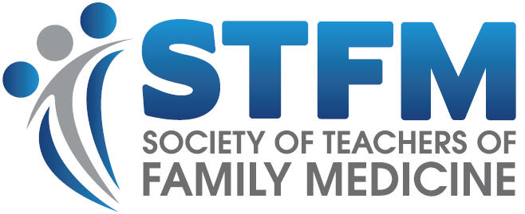
FPM Award for Practice Improvement
APPLICATION FORM

Name of primary care
practice organization:
Description (size, type of practice, etc.
Attach additional pages if necessary):
Address:
Street

City State Zip
Practice representative:
Name Position

Phone E-mail Fax
Please attach a description of your entry in 1,000 words or less, making sure you address the following points and attaching supporting evidence as needed:

1. Problem: What was the problem or challenge you addressed? Please give the clearest explanation you can of the scope and seriousness of the problems addressed. Supply any supporting data you have.

2. Solution: What did you do to address the problem? Describe how physicians and/or staff members arrived at and implemented a way to deal with the problem.

3. Results: What did you accomplish? Describe the improvement you achieved. Quantify the improvement as best you can and attach any supporting data and other exhibits you consider pertinent.

4. Applicability: What’s in it for other practices? Explain whether and how you think your practice improvement could be translated to other settings.

Your signature below signifies that you are duly empowered to represent the practice organization named and that you attest to the truth and accuracy of all information provided in your application for this award.

Signature of practice representative |  | Date
Printed name

SUBMITTING YOUR APPLICATION:

Applicants must submit a complete application and attachments (supporting materials) by June 1, 2020, to Leigh Ann Backer, c/o Conference on Practice Improvement, via e-mail at lbacker@aafp.org.

Disclosure for FPM Practice Improvement Award Applicants | 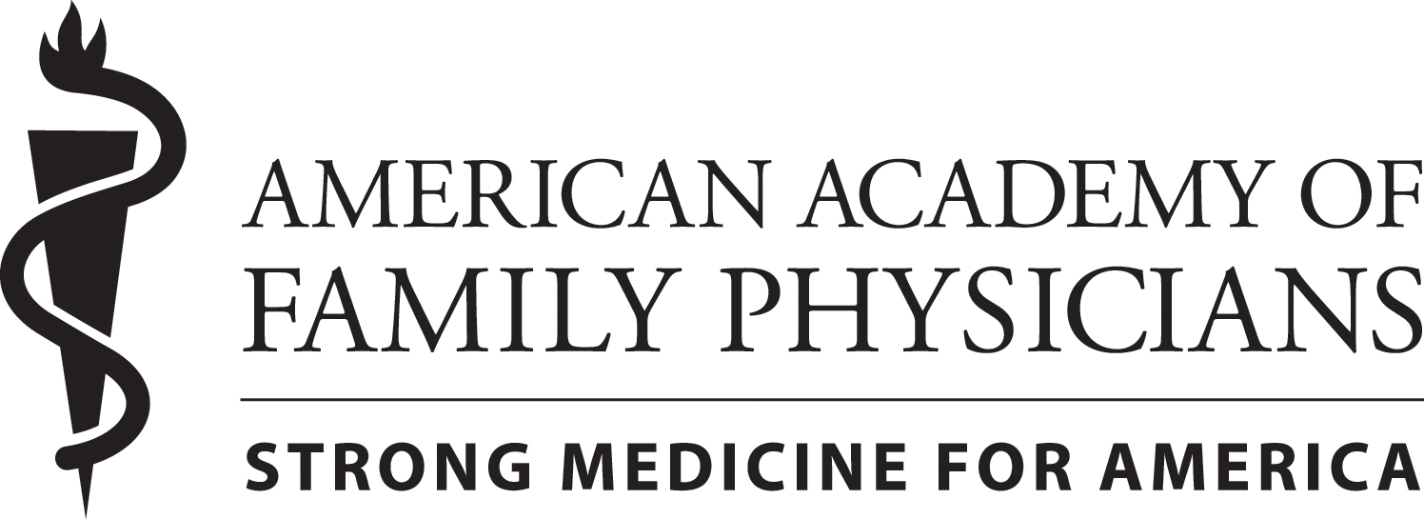

Name:___________________________________________________  Address: ___________________________________________________  ___________________________________________________ |  | Date: _____________________________  Phone: ____________________________________  E-mail: ____________________________________
Project title:

Disclosure of financial relationships within 36 months of the date of this form and within the foreseeable future:
A. Neither I nor any immediate family member (parent, sibling, spouse or child) has a financial relationship with or interest in any commercial entity that may have a direct interest in the subject matter of the project described in my application (i.e., any entity producing, marketing, re-selling, or distributing health care goods or services consumed by, or used on, patients).

B. I have or an immediate family member (parent, sibling, spouse or child) has a financial relationship or interest in a commercial entity that may have a direct interest in the subject matter of the project described in my application (i.e,any entity producing, marketing, re-selling, or distributing health care goods or services consumed by, or used on, patients). Please check all the types of relationship that apply:

Consultant or Advisory Board | Partnership
Employment | Receipt of equipment or supplies
Honorarium | Research Grants or support
Manuscript Preparation Assistance | Speakers’ Bureaus
Other financial support (please list) | Stock/Bond Holdings (excluding mutual funds)
Ownership
Other personal or professional relationships (please list:)
If you checked statement B above, please indicate the names of the organizations and the specific topic.

Organization with Which Relationship Exists | Topic Area(s) Involved
1. | 1.
2. | 2.
3. | 3.

Signature _________________________________________________________ Date: ___________________________

