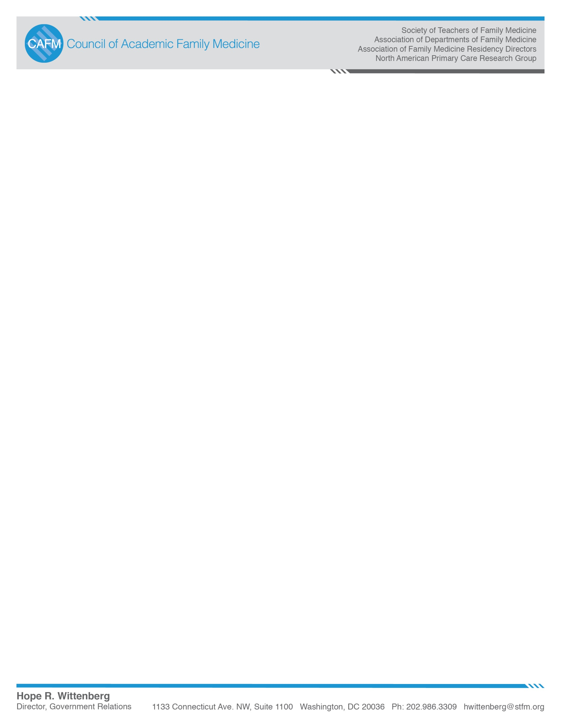

August 12, 2019

Administrator Seema Verma

Centers for Medicare & Medicaid Services

Department of Health and Human Services,

Attention: CMS–6082–NC

P.O. Box 8016

Baltimore, MD 21244–8016

Attention: CMS–6082–NC

Dear Administrator Verma,

On behalf of the Council of Academic Family Medicine (CAFM), including the Society of Teachers of Family Medicine, Association of Departments of Family Medicine, Association of Family Medicine Residency Directors, the North American Primary Care Research Group, we are pleased to submit comments in response to the Request for Information published in the June 11, 2019 *Federal Register*, titled Request for Information; Reducing Administrative Burden to Put Patients Over Paperwork.

Among the areas that CMS has solicited comment for which they are particularly interested in, we include recommendations in three areas: 1) documentation requirements, 2) overly burdensome policies, and 3) policies or regulations causing unintended consequences to rural settings.

**Documentation Requirements**

We applaud the efforts that CMS has made to date to help reduce the documentation burden of physicians generally, and specifically those related to student documentation. We appreciate the changes CMS has made to allow the teaching physicians to use verified student documentation rather than having to craft a full note of their own. In addition, the recognition that residents or nurses can demonstrate the presence of the teaching physician in the note is also a positive change in reducing the documentation burden of physicians. We also applaud the responsiveness of CMS to our request for the inclusion of proposed changes to the “CY 2020 Revisions to Payment Policies under the Physician Fee Schedule,” (RIN 0938-AT72) that extend the ability of advanced practice nurses and physician assistants to be among the professionals who furnish and bill for their professional services who may review and verify, rather than re-document, information included in the medical record by physicians, residents, nurses, students, or other members of the medical team.

We have written to CMS before regarding the need for additional clarity and support for other members of the care team, to be included in these positive changes. We believe CMS has gone a long way toward the goal of inclusion. We are hopeful that CMS is currently in the process of working to clarify some aspects of these changes and we include these areas of needed clarity again here to ensure that CMS entertains them as part of this request for information. Many institutions are not implementing the changes CMS has already made that allow a teaching physician to use a student note as part of the documentation in the patient’s record for billing of E&M codes. We understand that the bulk of the lack of implementation is due to concerns on the part of compliance officers related to lack of clarity of the guidance.

We have developed what we believe is a reasonable solution to this lack of clarity that will address outstanding questions of what “physical presence” entails, and what documentation is needed when residents are involved with students in training. Please see the five scenarios at the end of this communication that, if incorporated in the teaching physician guidelines, by way of a transmittal, would be a remedy that CMS can use to address the lack of clarity among compliance officers without requiring a change to regulation(s). Chapter 12 of the Medicare Claims Processing Manual Section 100.1.1 – Evaluation and Management (E/M) Services has a section A that discusses

“General Documentation Instructions and Common Scenarios.” These scenarios describe common situations involving the teaching physician and residents. We recommend adding the scenarios we have developed that address student involvement (both with and without resident involvement.)

***Additional Codes Needed for the Primary Care Exception (§§ 415.174):***

One of areas that we believe CMS can reduce overly burdensome policies that aren’t necessary to protect patient care is the inclusion of additional codes to the primary care exception of the Teaching Physician Rule. This exception has been in place since the mid 1990’s and has been an outstanding success. In the intervening years CMS has only added a few codes to this list (the annual wellness visit and the initial preventive for new Medicare beneficiaries (G0402, G0438, and G0439), yet, as CMS recognizes, practice has changed over the years. We believe CMS should recognize the extent of change in primary care practice and include additional codes, described below, into the primary care exception. This would only require a change to CMS program instructions, not regulation.

1. We request the inclusion of 99204 and 99214 E&M codes in the primary care exception.

The primary care exception was included in regulation in the mid 1990’s in acknowledgment by CMS that primary care residents need autonomous experience without being hampered by the insertion of a faculty member into patient care visits to develop the self-reliance necessary for independent ambulatory continuity practice as well as an independent, trusting relationship with a panel of patients. CMS implemented this concept by limiting the circumstances in which residents could see patients without the teaching physician’s presence. One of the limitations related to the complexity of the visits. Only less complex visit codes were allowed to be part of the exception.

Historically, CMS has only allowed E&M codes 99201-99203 and 99211-99213 to be included in the primary care exception to the teaching physician rule. This made sense at the time of the establishment of the exception, as the 99204s and 99214s were considered complex visits often involving patients with acute or unstable chronic conditions requiring the teaching physician to personally examine and assess the patient in order to assure a high standard of care. However, within the Medicare population it is not unusual to find patients with three or more chronic conditions presenting for new and follow-up visits that require a level of time and decision-making consistent with a level 4 code for management of multiple chronic conditions, but do not involve a level of diagnostic complexity that is beyond the resident physician’s ability to provide quality care with indirect supervision. In addition, in recent years, medical training has moved further toward competency-based assessment and rigorous standards have been put in place regarding supervision.

In fact, the ACGME has moved toward competency-based education by the development of the common program requirements. (<https://www.acgme.org/What-We-Do/Accreditation/Common-Program-Requirements> ) These requirements were developed specifically for the purpose of producing independent, well trained physicians in the context of patient safety. This is a concept CMS recognized when it developed regulations in the mid-90s that created the primary care exception. ACGME notes that “combined with gradually increasing authority and independence, supervision and feedback allow resident physicians to make the transition from novice learner to proficient practitioner at the completion of residency training. At the same time, excessive supervision without progressive independence, as resident physicians acquire knowledge and skills, may hamper their progression from learner to competent practitioner in their discipline.”(<https://www.acgme.org/What-We-Do/Accreditation/Clinical-Experience-and-Education-formerly-Duty-Hours/Research-and-Testimony> (Chapter 6 New Supervision Standards: Discussion And Justification))

These Common Program Requirements compel the establishment of Clinical Competency Committee (CCC) in each accredited residency and fellowship. The committee reviews all resident physicians twice a year, evaluating the resident physician’s progress. As part of those evaluations, the committee determines whether (and for what purposes) the resident physician is ready for direct vs indirect supervision.

With these internal processes in place, we believe it is both safe and advantageous for CMS to include the 99204 and 99214 E&M codes in the primary care exception. Our goal is to reduce unnecessary bureaucracy, not appropriate supervision. In fact, this change would free up preceptors to spend more time with resident physicians on complex and unstable patients, no matter what code is being billed.

1. We request the inclusion of additional codes relating to chronic care management, transition to care, home visits, group and virtual visits in the primary care exception.

In recent years CMS has included the annual wellness visit and the initial preventive for new Medicare beneficiaries (G0402, G0438, and G0439). Similar to the argument above, with the changing practice of medicine and teaching since the Primary care exception was put into place in the late 90’s we believe certain other codes should also be included in the Exception. For example, CMS has included new transition into care and chronic care management codes to pay separately for certain aspects of primary care services, but these codes have not been incorporated into the teaching situation of primary care education under the primary care exception . We request that they be added to the exception.

1. **Transition into Care**. These codes are specific to Medicare.  They are billed once the medical provider has met with the patient after discharge.  According to Medicare regulations, if the patient is not seen within 14 days of discharge this code cannot be used and an appropriate E & M code should be used. With each of these codes, face-to-face visits with a medical provider are required. We believe a resident physician should be considered an appropriate medical provider and they should be able to be billed by the teaching physician under the primary care exception.

**99495** – Transitional Care Management with moderate medical decision complexity (face-to-face visit with a medical provider w/in 14 days of discharge from an acute care hospital, psychiatric hospital, LTC hospital, SNF, inpatient rehabilitation, Hospital outpatient observation or partial hospitalization).

**99496** – Transitional Care Management with complex medical decision complexity (face-to-face visit with a medical provider w/in 7 days of discharge from an acute care hospital, psychiatric hospital, LTC hospital, SNF, inpatient rehabilitation, Hospital outpatient observation or partial hospitalization).

1. **Chronic Care Management (CCM)** – These services are mainly performed by clinical staff in support of the medical provider.  The actual face-to-face visit with a medical provider is an E & M code: 99212, 99213, 99214, 99215.  The CCM codes are a monthly code that is billed for the services performed by other clinical staff.

**99490 –**CCM; requires 20 minutes or more of clinical staff time

**99487 –**Complex CCM; requires 60 minutes of clinical staff time

**99489 –**Each additional 30 minutes of clinical staff time during the month; an add-on to 99487.

1. **Group visits, home visits, and virtual visits**. Similar to the codes addressed above, we request that CMS consider these visits as appropriate to be included as part of the Primary care exception. We recognize that CMS is in the process of making changes related to coding these visits, however once those decisions have been made and finalized, we believe that resident physicians should be considered appropriate medical providers and they should be able to be billed by the teaching physician under the primary care exception.

**Regulatory Change Needed: Apply the Primary Care Exception to Teaching Health Centers**

Under the Primary Care Exception, §415.174 (a)(1), the regulation states that “The services must be furnished in a center that is located in an outpatient department of a hospital or another ambulatory care entity in which the time spent by residents in patient care activities is included in determining intermediary payments to a hospital under §§413.75 through 413.83.

The intermediary payments refer back to Medicare GME payments. Given that payments made under the Teaching Health Center Graduate Medical Education (THCGME) program, for training residents are reimbursed under Section 340H of the Public Health Service Act, THC resident training does not fit the requirements of the primary care exception. This is due to the historic anomaly of the primary care exception being established in regulation approximately 15 years before the existence of the THCGME program. We request that CMS allow the primary care exception to apply to THCGME training as well as Medicare GME training. A simple addition, underscored below, to the regulation would permit this change:

§415.174 (a) (1), The services must be furnished in a center that is located in an outpatient department of a hospital or another ambulatory care entity in which the time spent by residents in patient care activities is included in determining intermediary payments to a hospital under §§413.75 through 413.83, or payments made under Section 340H of the Public Health Service Act.

**Policies or Regulations Causing Unintended Consequences to Rural Settings**

We very much appreciate the change included in the final rule regarding the FY2020 Hospital Inpatient Prospective Payment Systems (IPPS), ([CMS-1716-F] RIN 0938-AT73) regarding the ability of hospitals to count resident training time spent in critical access hospitals for graduate medical education payments. This change was something we had requested before and we are pleased that CMS has concurred with us and included this change. We would like CMS to entertain a few other changes to regulations or policies deleteriously affecting training in rural settings.

Our recommendations below stem from our belief that Medicare statutes and regulations should be changed – with a goal to promote rural physician training, rather than hinder or limit it. Of the needed changes, we believe several can be addressed in a regulatory fashion and the Centers for Medicare and Medicaid Services (CMS) has the authority to modify their current regulations, or their interpretation of their regulations, to further that goal. Below are three areas of concern and proposed policy solutions to address them that we believe can be dealt with in a regulatory fashion, without the need for legislative solutions. Other additional concerns, related to rural GME, would require legislative solutions.

1. **Remove Artificially Low Caps[1] and Per Resident Amounts[2] on Hospitals Accepting Rotating Residents for Limited Training Periods:**

Two major limitations in funding rural graduate medical education exist based on current rules, or CMS interpretation of current rules, regarding the establishment of caps and per resident amounts. Transient, partial training of residents in rural hospitals has resulted in artificially low caps on resident training for these hospitals, and artificially low per resident amounts (PRAs) associated with that hospital. While the rural hospital may expand its cap by establishing a new program, once the cap is reset, the program cannot expand in the future. Of even more concern, the PRA is set forever, even though the hospital has never sponsored a training program, making it unlikely that a hospital will ever be able to start a new training program.

**Solution needed:** Exempt rural hospitals from having a cap on resident positions (and the associated PRA) set if they are only training rotators from other institutions for brief periods of time. Hospitals that sponsor residency programs have a Designated Institutional Official (DIO,) so all hospitals with a DIO would be excluded from this request. For those hospitals where there is no DIO because another organization is the sponsor of the residency, the rubric should be “no claim, no trigger.” In other words, if the hospital isn’t claiming, or hasn’t claimed, costs for the training of those residents CMS should not establish a PRA, and the cap clock should not be started. This is in keeping with the sentiment expressed in current statute that discusses the limits “with respect to a hospital’s approved medical residency training program.” (§1886 DGME(h)(2) and (§1886 DGME(h)(2)(F)(i). The solution should be applied both prospectively AND retroactively. We recognize that this will not affect (help) hospitals whose cap was set due to residents rotating through in 1996 due to the statutory language of the BBA, and we are working on legislation to help I those instances, but CMS can make changes to its interpretation of its own regulations to help current and future situations.

1. **Allow Urban Hospitals to Establish Rural Training Tracks[3] Whenever and Wherever Feasible:**

The Balanced Budget Act of 1997 (BBA) established the concept that an urban hospital would be able to increase its cap on residency positions in order to accommodate residents training in rural areas as part of a rural training track (RTT) after the first year of training. The purpose was to allow the residents to obtain enough inpatient training at the urban hospital serving a larger and broader patient population in the first year, and then train in rural, community-based settings for the rest of the residency. In addition, the BBA also states that Rural training track (RTT) residency programs are a proven model for addressing rural physician workforce shortages, with over 70% of graduates practicing in rural areas. Most RTTs still do not receive full GME funding for the rural portion of their programs.[4]

Unfortunately, there are two problems related to rural training tracks that need to be addressed. One problem is the inability of the urban hospital to establish an additional new training track at another rural site in the same specialty. CMS has interpreted the statute to mean that once a cap is set for the establishment of a rural training track, no new training tracks will be allowed in the same specialty, even if they are at different rural locations. It is viewed by CMS as an expansion of a current residency program, the funding for which is not allowed in statute, rather than the establishment of a new program training in a new setting for the 2nd and 3rd years. The second, similar, concern is that once a cap is set for a RTT, for the training in the rural setting, there is no further ability to claim additional RTT residents at the urban hospital for related to training at that site. This means a RTT at a rural site can never grow in size. While in line with limits established for all urban hospitals, we maintain that it does not make sense for Medicare to limit rural training. Rather, regulation should promote training in rural communities as a way of increasing the numbers of physicians who would practice there. This is in concordance with the statute which states that:

`(i) NEW FACILITIES- The Secretary shall, **consistent with the principles** [emphasis added] of subparagraphs (F)[5] and (G), prescribe rules for the application of such subparagraphs in the case of medical residency training programs established on or after January 1, 1995. In promulgating such rules for purposes of subparagraph (F), the Secretary **shall give special consideration to facilities that meet the needs of underserved rural areas** [emphasis added**.]**

**Solutions needed:** 1) Revise the regulations to allow an urban hospital to expand its cap for the purposes of establishing a new RTT (training at a new site) whenever they occur and in whatever specialty they train. The limits on an urban hospital’s cap should not be limited solely to concurrent RTT startups. The establishment of a RTT in a new community should be considered a "new RTT" rather than an expansion of an existing RTT, for the purposes of cap-setting in both the urban “mother” hospital and in the rural hospital, no matter when it is established.

This can be done by revising the definition of new programs established under § 413.79 (e) New medical residency training programs. All full time equivalent (FTE) residents training in a RTT should be counted and added to the urban hospital’s cap; and 2) Revise regulations to allow the cap for urban hospitals’ expansion to be set at the actual level of FTE residents who are designated to train in rural areas for PGY2 and PGY3. This effectively would eliminate the additional cap on urban hospitals associated with the additional residents training in RTTs by allowing the cap to be expanded over time so that all FTE residents training in a RTT would be counted and added to the urban hospital’s cap.

1. **CMS Should not Apply a Rolling Average During the Cap-Setting Period of RTTs:**

CMS implemented a new policy regarding rolling averages for RTTs during their cap-setting periods as part of their FY17 regulation which updates annually the Inpatient Prospective Payment System (IPPS) rates. The proposal stated that “due to the statutory language at sections 1886(d)(5)(B) and 1886(h)(4)(H)(iv) of the Act as implemented in our regulations at §§ 412.105(f)(1)(v)(F) and 413.79(d)(7), except for new rural track programs begun by urban teaching hospitals that are establishing an FTE cap for the first time, FTE residents in a RTT at the urban hospital are subject immediately to the 3-year rolling average for direct GME and IME.” In other words, unless the hospital is a brand new teaching hospital, the three-year rolling average will continue to apply to resident FTEs training in the rural track program, even during the five-year RTT cap-building window. We are concerned that the impact of the application of the rolling average to new RTTs is extremely detrimental to institutions’ ability to establish new RTTs. Instead, CMS should pay for the entire direct and indirect costs of RTT residents, including during the growth window. We believe CMS continues to take an unduly cramped reading of its statutory authority. That authority, stated above, clearly establishes “special rules” to support training of physicians in rural areas.

For the purpose of providing adjustments to the limitations for hospitals establishing residency training programs in rural areas and giving special consideration for new facilities, CMS should not apply the rolling average at the inception of the RTT to help address the nation’s need of physicians for these areas. We believe that the special consideration for new facilities should apply because for greater than 50 percent of the time the programs’ residents will be situated in a new facility – a new training site – and not in the urban “mother” hospital. Basically the effect of this rule is that urban hospitals will lose one complete years’ worth of claims for RTT FTEs. That loss will be spread over 2-4 years, but will be a net loss. The hospital will have to absorb these early losses. The dollar amount of these lost resident FTE claims can be very high and likely to present an insurmountable barrier for many rural communities contemplating starting a training program. This is actually a major financing problem for the start-ups, as only getting 1/3 of the money possible for the first residents and not coming to full funding until 5 years out is another make-or-break issue for many places looking to do this where there is already not enough money available.  Assuming that 1 FTE resident claim on a cost report generates ~$150,000 in Medicare DGME and IME claims the loss with the rolling average rule will amount to $300,000 to $900,000 in various scenarios for a 2-2-2 rural training track. (personal communication Louis Sanner, MD, May 4, 2016)

**Solution Needed**: Revise regulations so that RTTs are not subject to the rolling average of residents at the main program/hospital. Instead, they should be treated as a “new” program with full reimbursement of resident costs from the first day of training.

In conclusion, we appreciate the efforts of CMS to minimize the documentation and administrative burdens of physicians and other providers. In addition we are supportive of the changes included in recent CMS proposed and final rules dealing with such documentation changes, as well as rural GME training at Critical Access Hospitals. We are pleased to be able to submit under this request for information regarding additional changes that we believe CMS can make to reduce administrative burden and support patients over paperwork.

Sincerely,



Freddy Chen, MD, MPH

President

Society of Teachers of Family Medicine



Deborah S Clements, MD

President

Association of Family Medicine Residency Directors

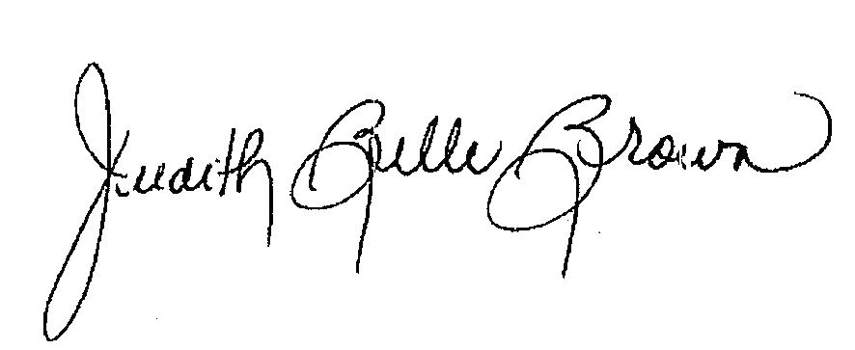

Judith Belle Brown, PhD

President

North American Primary Care Research Group



Allen Perkins, MD, MPH

President

Association of Departments of Family Medicine

Scenarios taken from <https://www.cms.gov/Regulations-and-Guidance/Guidance/Transmittals/2018Downloads/R4068CP.pdf>but edited for inclusion of students and/or students and residents in the changes in Transmittal R4283CP, dated August 26, 2019.

**Scenario 1:** The teaching physician personally performs all the required elements of an E/M service without a student. In this scenario the student may or may not have performed an E/M service independently. In the absence of documentation by a student, the teaching physician must document as he/she would document an E/M service in a nonteaching setting.

**Scenario 2:** The student performs the elements required for an E/M service in the presence of, or jointly with, the teaching physician and the student documents the service. The teaching physician performs or re-performs the HPI and the physical exam, and participates in the medical decision making. The teaching physician verifies* the student’s entry in the patient’s record. For payment, the composite note must support the medical necessity and the level of the service billed by the teaching physician.

**Scenario 3:** The student performs some or all of the required elements of the service in the absence of the teaching physician and documents in the patient record. The teaching physician independently performs the HPI, the physical exam, and medical decision making with or without the student present. The teaching physician verifies* the student’s entry in the patient’s record. For payment, the composite note must support the medical necessity and the level of the service billed by the teaching physician.

**Scenario 4:** The student performs some or all of the required elements of the service in the presence of, jointly with, or in the absence of the resident and documents in the patient record. The resident performs some or all of the required elements of the service in the absence of the teaching physician with or without the student present. The resident verifies* the student’s entry in the patient’s record and attests that he/she (the resident) performed the required elements of the service. The teaching physician independently performs the critical or key portions of the service and participates in the management of the patient. The teaching physician verifies* the composite entry in the patient’s record. For payment, the composite note must support the medical necessity and the level of the service billed by the teaching physician.

**Scenario 5:** The student performs some or all of the required elements of the service in the presence of, jointly with, or in the absence of the resident and documents in the patient record. The resident performs some or all of the required elements of the service in the presence of, or jointly with the teaching physician with or without the student present. The resident verifies* the student note and attests that he/she (the resident) performed the required elements of the service. The teaching physician verifies* the composite entry in the patient’s record. For payment, the composite note must support the medical necessity and the level of the service billed by the teaching physician.

*Verify: review and ensure the documentation is true and accurate. This includes editing as needed

1. The Balanced Budget Act of 1997 (BBA) limited the number of allopathic and osteopathic medical residents that would be counted for purposes of calculating Medicare indirect medical education (IME) and direct graduate medical education (DGME) reimbursement to the unweighted number on each hospital's most recent cost report as of December 31, 1996 (BBA Section 4621). Effective October 1, 1997, to the extent the number of allopathic or osteopathic residents being trained at a teaching hospital exceeds the 1996 limit, teaching hospitals receive no additional IME or DGME payments; podiatry and dental residents are excluded from the resident limits. The Balanced Budget Refinement Act of 1999 (BBRA) increased the limit for rural teaching hospitals to equal 130% of each rural teaching hospital's 1996 resident count (BBRA Section 407).
2. Officially part of the calculation for determining Direct GME payments, used in this paper as a proxy for the amount an institution is reimbursed globally for the training of one FTE resident per year.
3. Rural Training Track (RTT) residency programs provide graduate medical education to prepare resident physicians broadly for rural family medicine. The most popular model is the “1-2” RTT. In “1-2” programs, the first year of residency takes place in an urban-based program setting while the second and third years occur in a more rural area. This model capitalizes upon the best training opportunities in both contexts.
4. Rural Training Track Technical Assistance Program. http://www.raconline.org/rtt/about_rtts
5. `(F) LIMITATION ON NUMBER OF RESIDENTS IN ALLOPATHIC AND OSTEOPATHIC MEDICINE- Such rules shall provide that for purposes of a cost reporting period beginning on or after October 1, 1997, the total number of full-time equivalent residents before application of weighting factors (as determined under this paragraph) with respect to a hospital's approved medical residency training program in the fields of allopathic medicine and osteopathic medicine may not exceed the number of such full-time equivalent residents for the hospital's most recent cost reporting period ending on or before December 31, 1996.