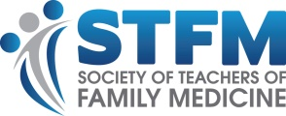
Sample Newsletter Article
Headline: Receive ABFM Performance Improvement Credit (MOC IV) for Teaching
(Your Program/School Name) has been approved as a Sponsor of American Board of Family Medicine (ABFM) Performance Improvement Credit (MOC Part IV). This credit is available to those who precept (your program name’s) medical students, residents, or fellows and who participate in a teaching improvement activity.

To receive the ABFM credit, family physicians need to:
- Complete at least 180 1:1 contact hours with a resident, fellow, or student
- Participate in an intervention to improve teaching skills
- Review and reflect on the results of the intervention
- Complete an attestation

Once preceptors complete the requirements, (Your Program Name) submits the completion information to ABFM. To participate and receive credit, preceptors should contact (Your Contact Information).

Learn more about the program at https://theabfm.mymocam.com/precepting/

