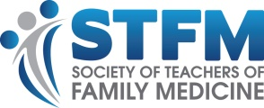
Sample Email to Preceptors
Subject Line: Receive ABFM Performance Improvement Credit for Teaching
(Your Program Name) has been approved as a Sponsor of American Board of Family Medicine (ABFM) Performance Improvement Credit (MOC Part IV). This means you can now earn MOC Part IV credit for teaching (your program name’s) medical students, residents, or fellows and participating in a teaching improvement activity.

To receive the ABFM credit, you will need to:
- Complete at least 180 1:1 contact hours with a resident, fellow, or student
- Participate in an intervention to improve teaching skills
- Review and reflect on the results of the intervention
- Complete an attestation

If you’d like to earn this credit, we will work with you to complete this intervention: (describe your intervention here. Interventions might include an online course, a faculty development workshop or other agreed-upon activities to enhance skills). Once you complete the teaching and the intervention, we’ll submit the completion information to ABFM.

To get started, email (Your Contact Information).

Thanks for all you do to educate the next generation of family physicians.
(Your Electronic Signature).

